South Walton Expansion Committee Meeting
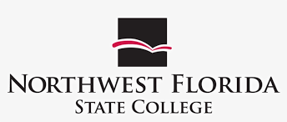

Northwest Florida State College
Jan 5, 2023 at 2:00 PM CST to Jan 5, 2023 at 3:00 PM CST
Raider Central, Building 400, Room 308, Niceville Campus, 100 College Blvd E, Niceville, FL 32578

Agenda
- Call to Order
- Agenda
  - Review of Updated MOU
Presenter: Whitney Rutherford
- Next Steps
  - Schedule Next Meeting
- Public Comments
- Adjourn

